Research Article for J. Electrochem. Sci. Technol.

Supplementary Information

Effect of Iron Species in mesoporous Fe-N/C Catalysts with different shapes on Activity towards Oxygen Reduction Reaction

Taehong Kang#, Jiyeon Lee#, Jong Gyeong Kim and Chanho Pak*
Graduate Program of Energy Technology, School of Integrated Technology, Institute of Integrated Technology, Gwangju Institute of Science and Technology, Gwangju, 61005 (Korea)

*Corresponding author: Chanho.pak@gist.ac.kr
#These authors made equal contributions to this work.

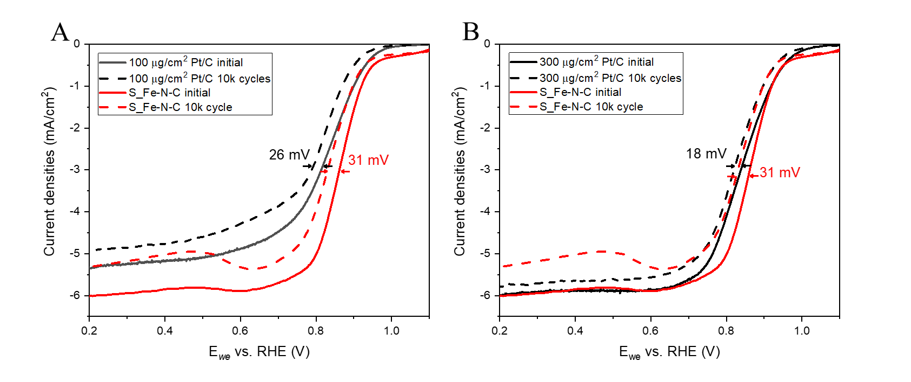
Figure S1. Linear sweep voltammogram before and after durability test of S_Fe-N-C and Pt/C. Amount of Pt/C was adjusted to 100 μg/cm² (A) and 300 μg/cm² (B), respectively.

