[Supporting information]

Electrochemical capacitance of activated carbons regenerated using thermal and chemical activation

Jung Eun Park¹, Gi Bbum Lee¹, Sang Youp Hwang^{2,*}

¹Bio Resource Center, Institute for Advanced Engineering, Yongin 17180, Korea
²Department of Energy Engineering, Konkuk University, 120 Neungdong-ro, Gwangjin-gu, Seoul 05029, Republic of Korea

* Corresponding author.
E-mail address: syhwang80@gmail.com (S. Y. Hwang)
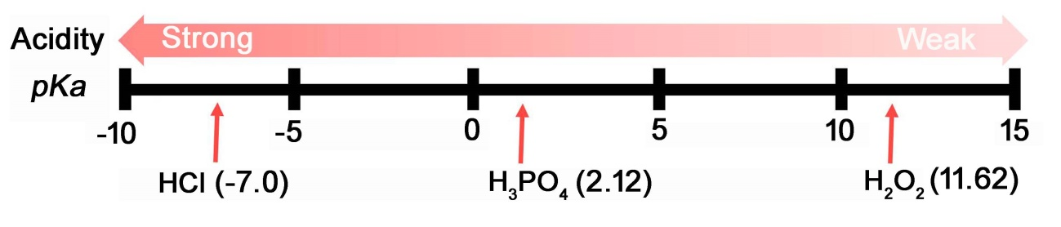
Fig. S1. Relative acidity and pKa value of HCl, H₃PO₄, and H₂O₂ [1-3].

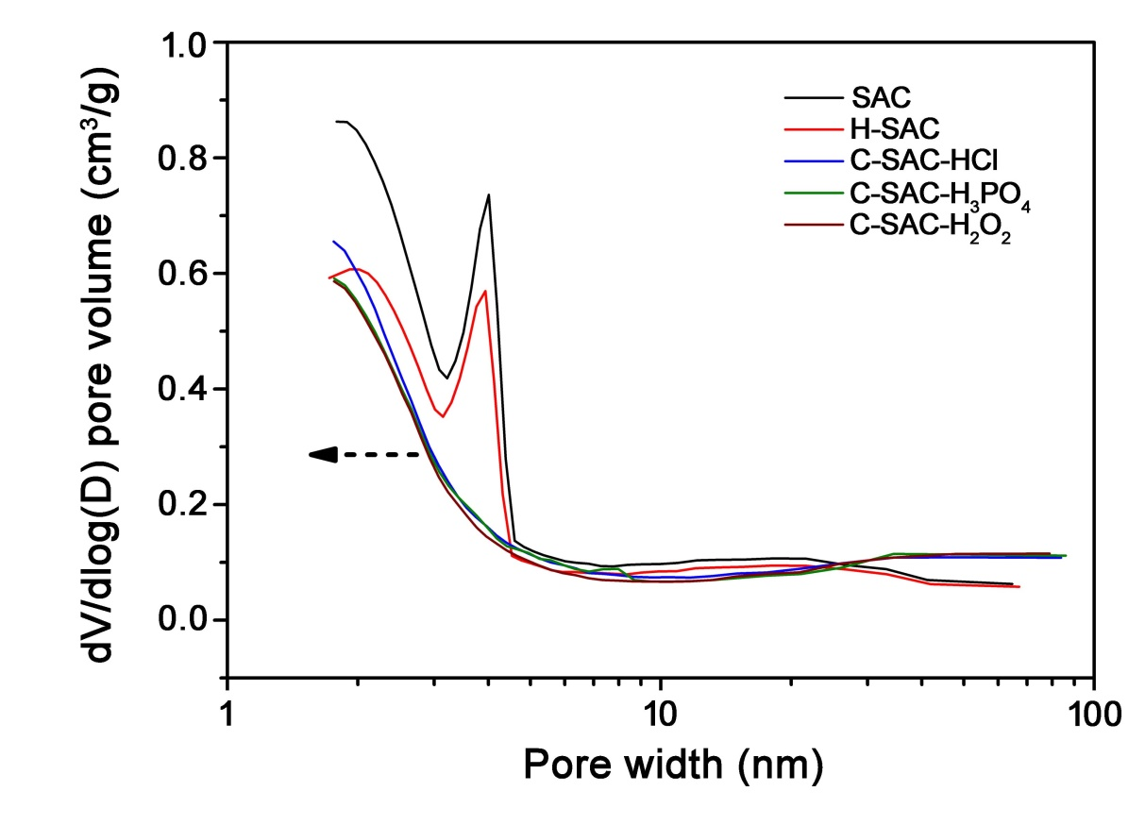
Fig. S2. Pore size distribution of SAC, H-SAC, C-SAC-HCl, C-SAC-H₃PO₄, and C-SAC-H₂O₂.

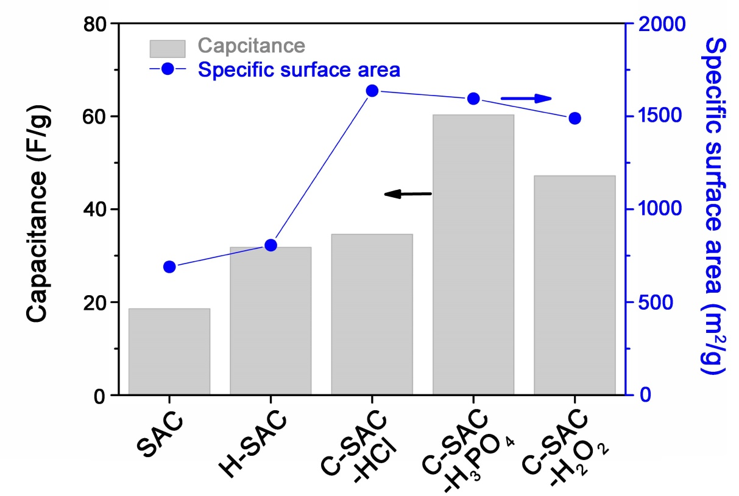
Fig. S3. Comparison of capacitance at the scan rate of 200 mV/s and specific surface area of SAC, H-SAC, C-SAC-HCl, C-SAC-H₃PO₄, and C-SAC-H₂O₂.

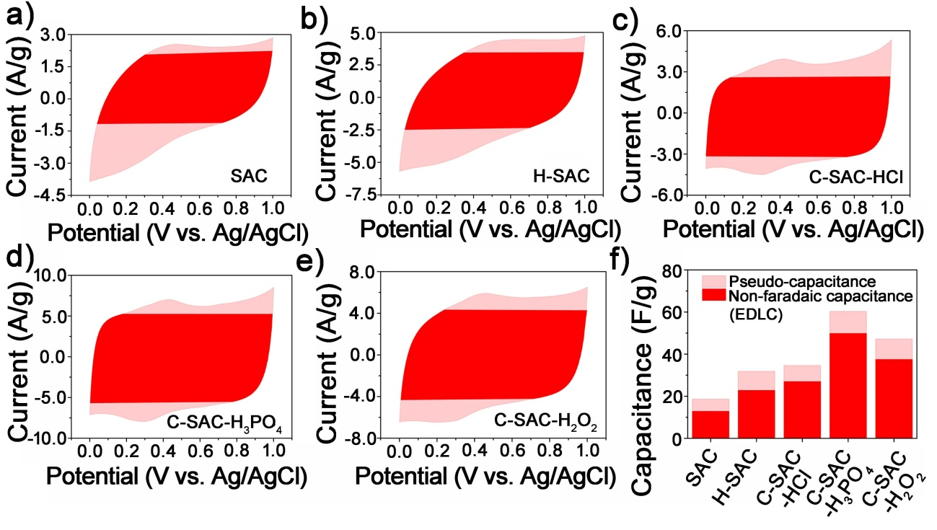
Fig. S4. CV curves showing the rectangular non-faradaic (red) and pseudo capacitance area (pink) of SAC (a), H-SAC (b), C-SAC-HCl (c), C-SAC-H₃PO₄ (d), and C-SAC-H₂O₂ (e), and comparison of the each capacitance (d) with a scan rate of 200 mV/s.

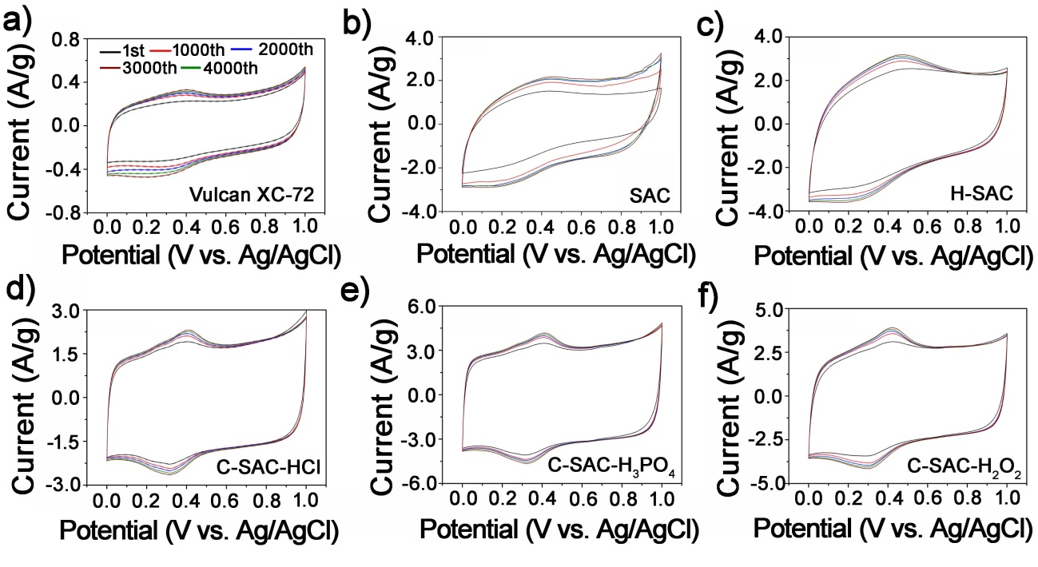
Fig. S5. CV curves at each 1000th cycle (tested up to 4000th cycles) of SAC (a), H-SAC (b), C-SAC-HCl (c), C-SAC-H₃PO₄ (d), and C-SAC-H₂O₂ (e) with a scan rate of 100 mV/s.

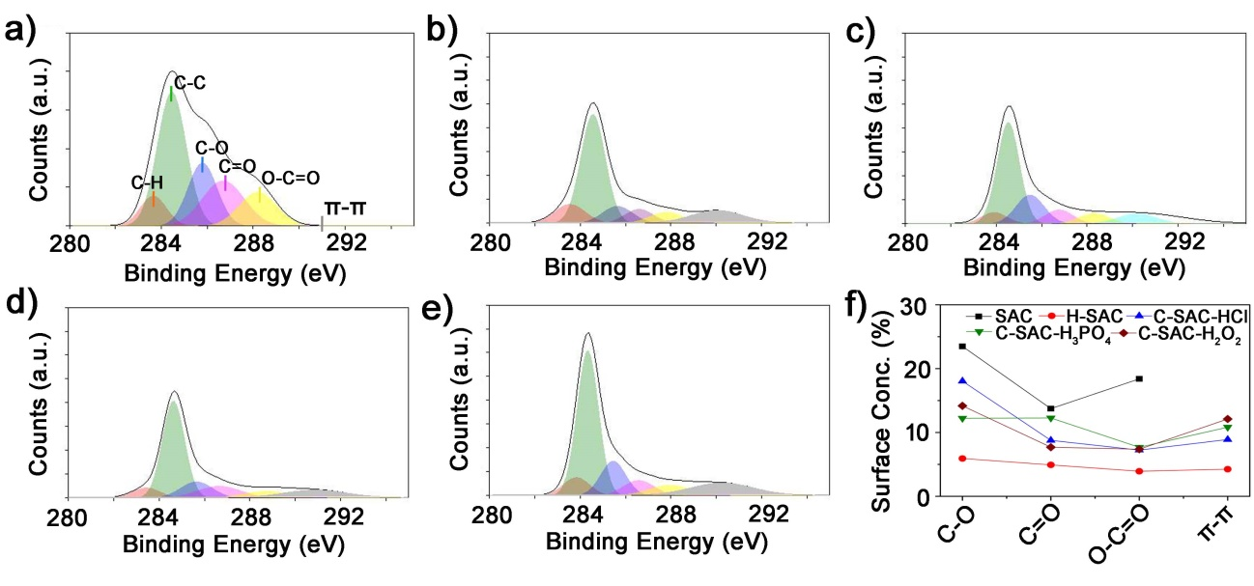
Fig. S6. XPS analyses of (a) SAC, (b) H-SAC, (c) C-SAC-HCl, (d) C-SAC-H₃PO₄, and (e) C-SAC-H₂O₂ [4]. Surface concentration changes (from C1 peak) based on the XPS areas (f).

Table S1. Relative concentration of the different groups in the C1s peak based on XPS analyses [4].
 | Surface concentration (from C 1s peak) of (% at.):
B.E. (eV) | 283.6 - 284.2 | 284.6 - 284.8 | 285.5 - 285.6 | 286.7 - 286.8 | 288.8 - 289.0 | 290.6 - 291.1 | Sum of oxygen functional groups (%)
(Assign) | (C-H) | (C-C) | (C-O  /C-O-C) | (C=O) | (O-C=O) | (π-π)
SAC | 7.80 | 36.55 | 23.49 | 13.73 | 18.40 | - | 55.62
H-SAC | 6.59 | 37.61 | 5.92 | 4.92 | 3.92 | 4.25 | 14.76
C-SAC- HCl | 6.56 | 50.45 | 18.05 | 8.77 | 7.24 | 8.90 | 34.06
C-SAC-H₃PO₄ | 6.91 | 50.10 | 12.23 | 12.27 | 7.68 | 10.83 | 32.18
C-SAC-H₂O₂ | 7.87 | 50.77 | 14.18 | 7.69 | 7.37 | 12.12 | 29.24

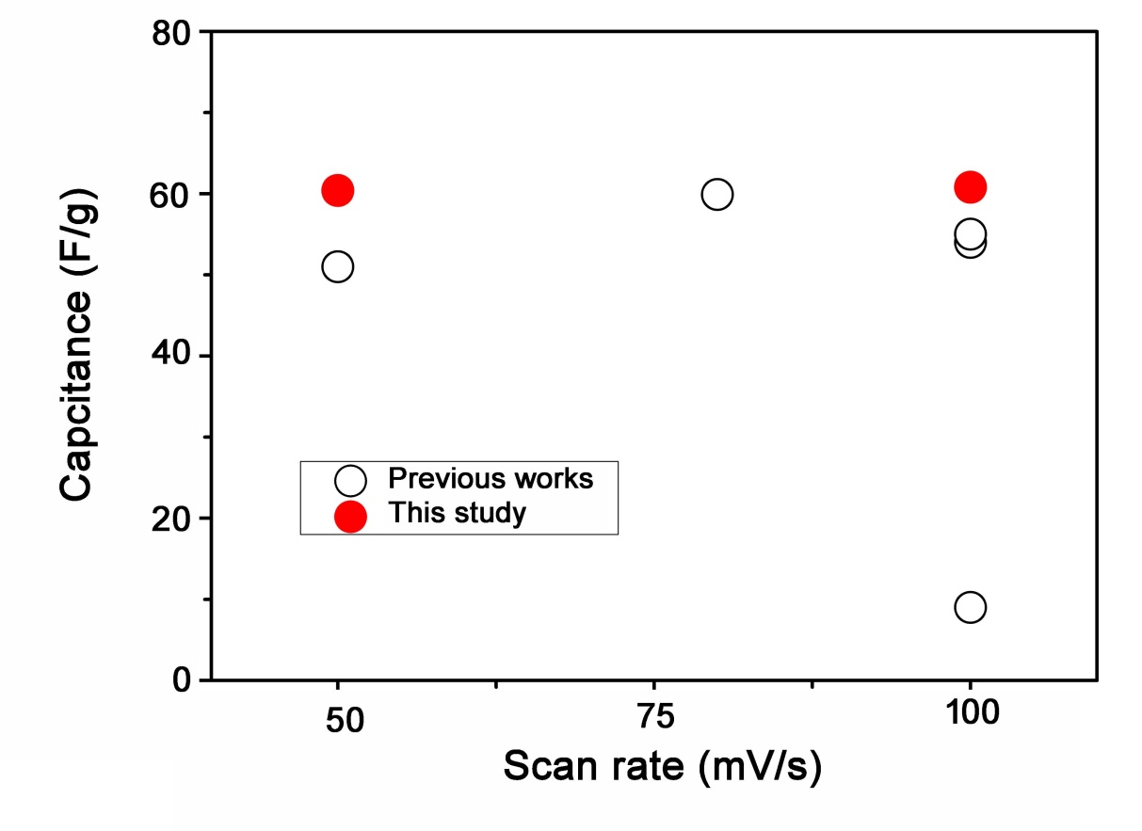
Fig. S7. Comparison of specific capacitance from the previous reports and this works [5-9].

References
- M. D. Curtis, J Organomet Chem., 1978. 149 C26.
- P. W. Atkin, Physical Chemistry 6th ed., Oxford University Press, New York, 1998.
- V. K. Chaudhri, V. K. Chaudhri, B. E. John, S. Mishra, J. Pacheco, B. Porter, A. Spaulding, K-CAP’07: Proceedings of the Fourth International Conference on Knowledge Capture, 2007, 159.
- J.E. Park, G.B. Lee, B.U. Hong, S.Y. Hwang, Appl. Sci., 2019, 9, 5132
- K. Chaitra, R. T. Vinny, P. Sivaraman, N. Reddy, C. Hu, K. Venkatesh, C. S. Vivek, N. Nagaraju and N. Kathyayini, J. Energy Chem., 2017, 26, 56.
- V. Subramanian, C. Luo, A. M. Stephan, K. S. Nahm, S. Thomas and B. Wei, J. Phys. Chem. C, 2007, 111, 7527.
- C. Kim, J. W. Lee, J. H. Kim and K. S. Yang, Korean J. Chem. Eng., 2006, 23, 592.
- C. S. Yang, Y. S. Jang and H.K. Jeong, Curr Appl Phys., 2014, 14, 1616.
- S. Kumagai, M. Sato and D. Tashima, Electrochim Acta., 2013, 114, 617.

